**Lab MST Performa (Disruptive Technologies-1)**

**Section: 22BCB-124 Group: A**

Title of the Project: **Cyberbullying Classifier**

Names and UIDS of group members:

**Ankush Singh (22BCT10002)**

**Prayrit Dhingra (22BCT10015)**

**Harsh Saini (22BCT10007)**

**Moksh Verma (22BCT10059)**

**Md Karimul Hasan (22BCT10001)**

Problem statement:

**Often people are targeted and cyberbullied on social media platforms like Discord, Twitter, Reddit and Instagram. We aim to make a text classifier that classifies tweets from twitter as ‘not_cyberbullying’ or ‘cyberbullying’ with it’s type – racial, age based, gender based, etc.**

Key Features/Benefits:

* **Attempt to detect Cyberbullying from posts on social media.**
* **Text Classification using SVMs (Support Vector Machines)**
* **Dataset used : 46 thousand labeled tweets from twitter**
* **Detect and prevent Racism, Sexism, Religionism, etc**

Software used:

* **Python3, Google Colab/Jupyter notebook**
* **Github for code collaboration**
* **Pandas, Numpy, Matplotlib**
* **PyCaret, Tensorflow**
* **Kaggle Platform**

Deliverables:

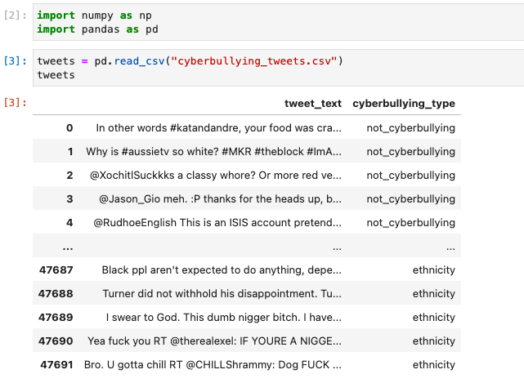

1: Vulgar Speech Dataset (40thousand + columns)

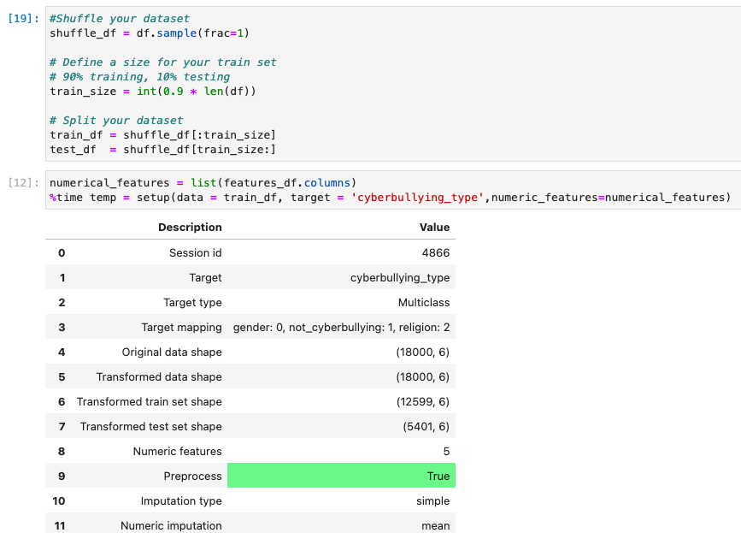

2: Splitting dataset into training and testing parts

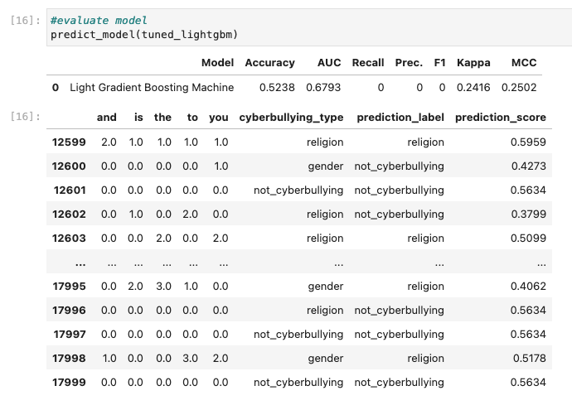

: Testing our trained model

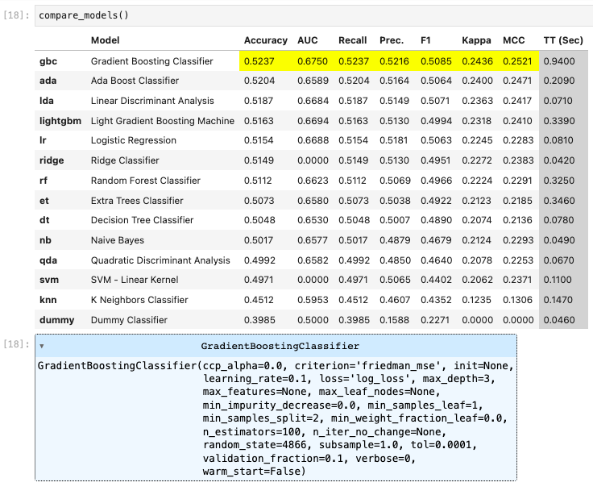

4: Comparing accuracy with different models